**VPN: (Virtual Private Network)**Creating a secure tunnel over an unsecure network, such as internet is called vpn.  
 **🔹 Route-Based VPN**

* **Traffic Control**: Uses routing tables and tunnel interfaces (like virtual interfaces) to send traffic through the VPN.
* **Tunnel Interface**: Creates a logical tunnel interface (e.g., Tunnel0) and routes traffic to that interface.
* **Flexibility**: More flexible and scalable; supports dynamic routing protocols (like OSPF, BGP).
* **Use Case**: Preferred for site-to-site VPNs with complex topologies, multiple subnets, or dynamic routing needs.
* **It encrypts all the data that goes through the interface**.

**Command:**ip route 192.168.2.0 255.255.255.0 Tunnel0  
  
**🔹 Policy-Based VPN**

* **Traffic Control**: Uses Access Control Lists (ACLs) or Security Policies to specify which traffic should go through the VPN.
* **Tunnel Interface**: No dedicated tunnel interface — traffic is matched to policies.
* **Simplicity**: Simpler to configure for small, static environments.
* **Limitations**: Does not support dynamic routing or multiple subnets easily.
* **If the traffic matches the policy, it’s encrypted by IPSec.**

**Command**:

access-list VPN_ACL permit ip 192.168.1.0 0.0.0.255 192.168.2.0 0.0.0.255

crypto map VPN_MAP 10 match address VPN_ACL

**Q. Where do we assign IP to the tunnel?**

We assign an IP **only in Route-Based VPNs**, because they use a **virtual tunnel interface** (VTI) — a logical interface that behaves like a physical network interface.

**✅ Where it's assigned:**

* The IP address is assigned to the **Tunnel Interface** (e.g., Tunnel0 on Cisco routers or ipsec0 on Juniper/FortiGate).

**🔧 Example (Cisco Router):**

interface Tunnel0

ip address 10.0.0.1 255.255.255.252

tunnel source <int-name> or <ipv4-address>

tunnel destination 203.0.113.1

**🔐 IPSec Modes: Tunnel vs Transport**

**🔹 Tunnel Mode (default for VPNs)**

* **Used in:** Site-to-Site VPNs (both Route-Based and Policy-Based)
* **Encapsulation:**
  + Entire original IP packet is encapsulated.
  + A new IP header is added.
* **Result:** New outer IP header = Yes ✅

**🔹 Transport Mode**

* **Used in:** End-to-End encryption (like between two hosts or for securing traffic between client and server — e.g., SSL VPNs, remote access)
* **Encapsulation:**
  + Only the payload of the original IP packet is encrypted.
  + No new IP header is added — original IP header is kept.
* **Result:** New outer IP header = No ❌

**Q. When new ip header is attached?**

It depends on the type of ipsec mode used while creating the tunnel. If the **ipsec mode is tunnet** then it will attach the new ip header but ipsec over transport mode does not attach any new ip header.

**Q. Why the router chooses the next hop as tunnel interface not the isp side router as a next-hop when we configure dynamic route?**Because the router-based VPNs chooses the traffic based on the routing table, and tunnel interface behaves like directly connected with the other network even if it goes by ISP. That is why the router chooses tunnel interface as the best path.

**IPSEC:**  
Ipsec is suit of protocols used to create secure tunnel between two   
end- host. It only allows unicast traffic flows through the tunnel. It doesn’t allow multicast or other non-ip protocols like appletalk, ipx.  
In order to allow multicast traffic through the tunnel, we need to use gre or vti using route based vpn configuration.  
15

**Remote Access vpn:**If a user wants to connect to an organization network. He tries to connect with a server which gives an IP address of that organization network, then the client connects with the organization network as if he is locally connected with them. **SSL (Secure Socket Layer):**This vpn is used to connect a web browser with an organisation securely.   
SSL based VPNs are used to allow remote users to connect to their central network via a normal Web Browser with SSL encryption.

**client based vpn (Web VPN):**It lets users establish a secure remote access VPN tunnel using just a Web browser.

**AnyConnect Web vpn (Software based VPN):**   
A special Java based client is installed on the user’s computer providing an SSL secure tunnel to the central site. Provides full network connectivity (similar with IPSec Remote Access client). All applications and network resources at the central site can be accessed remotely.

SSL VPN (clientless/web/ proxy vpn):  
Here we create vpn tunnel between client and asa.

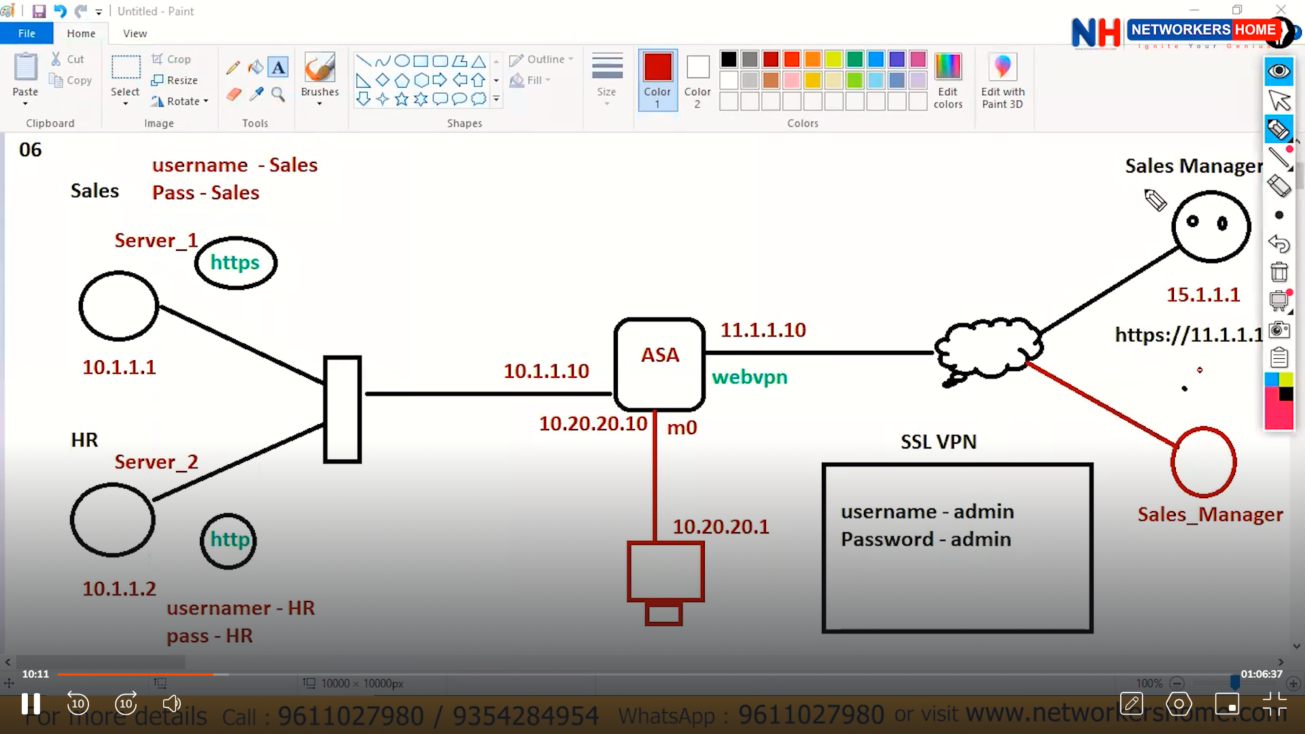

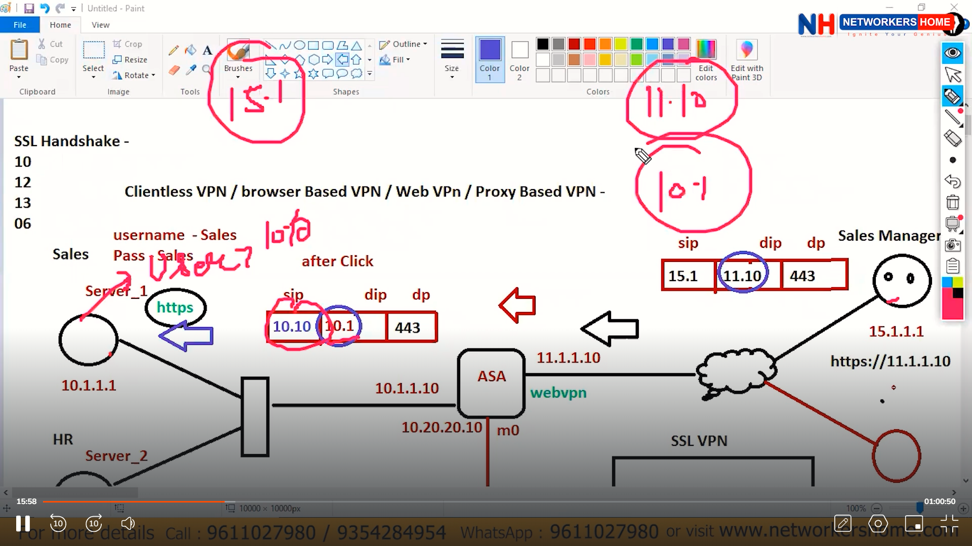

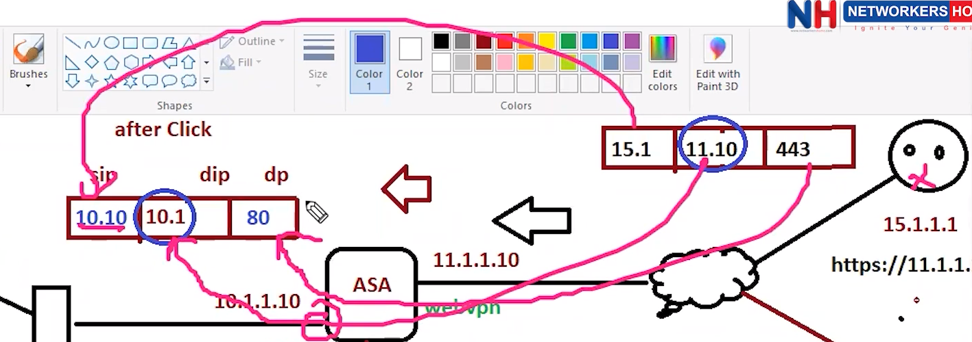  
The above concept where sip conversion from 15.1 – 10.10  
 and dip conversion from 11.10 – 10.1   
 and port conversion form 443 - 80  
is called proxy vpn.

In clientless/web based vpn, we have limited access of the server like http, https, ftp,   
cifs (common internet file system) Enables file and printer sharing over a network.  
  
Possible Errors: this error comes when we don’t configure http on the router.  
Server <ip> not available

If we want to change the port no manually for http or https:  
ip http port 8080

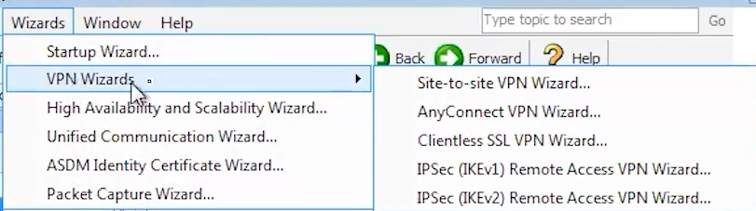

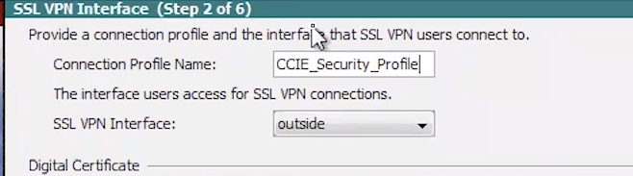

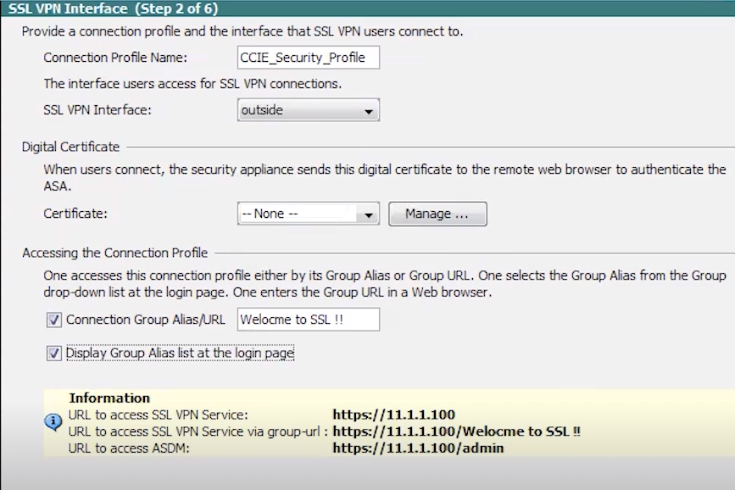

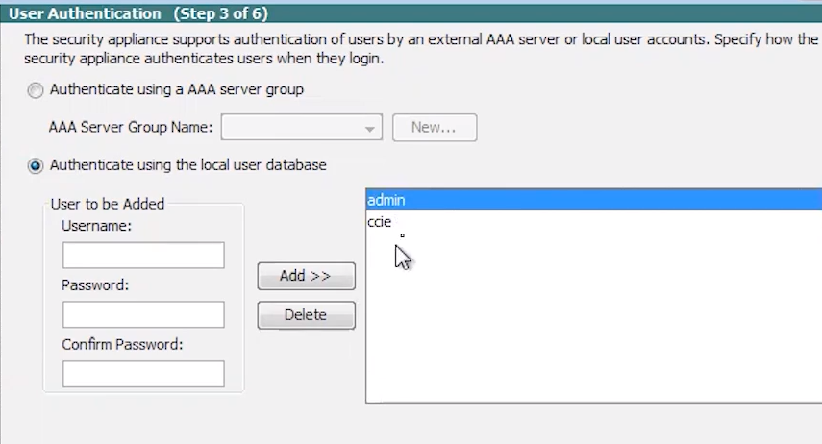  
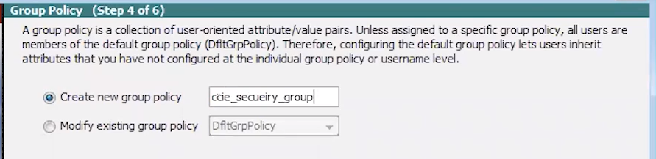  
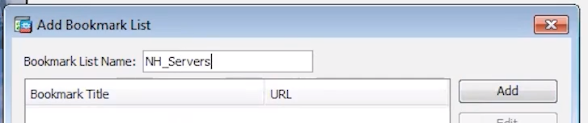  
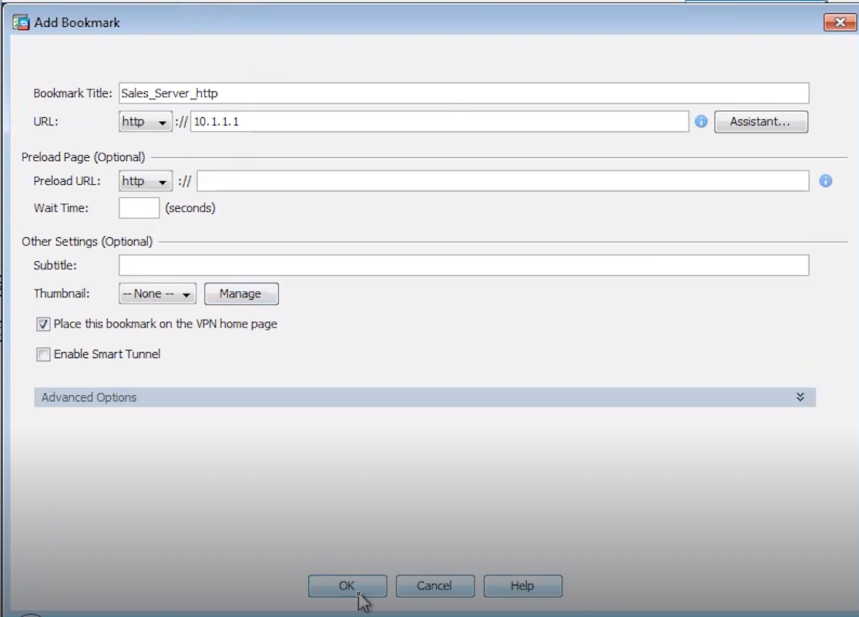

Create – http/https

Without gui:  
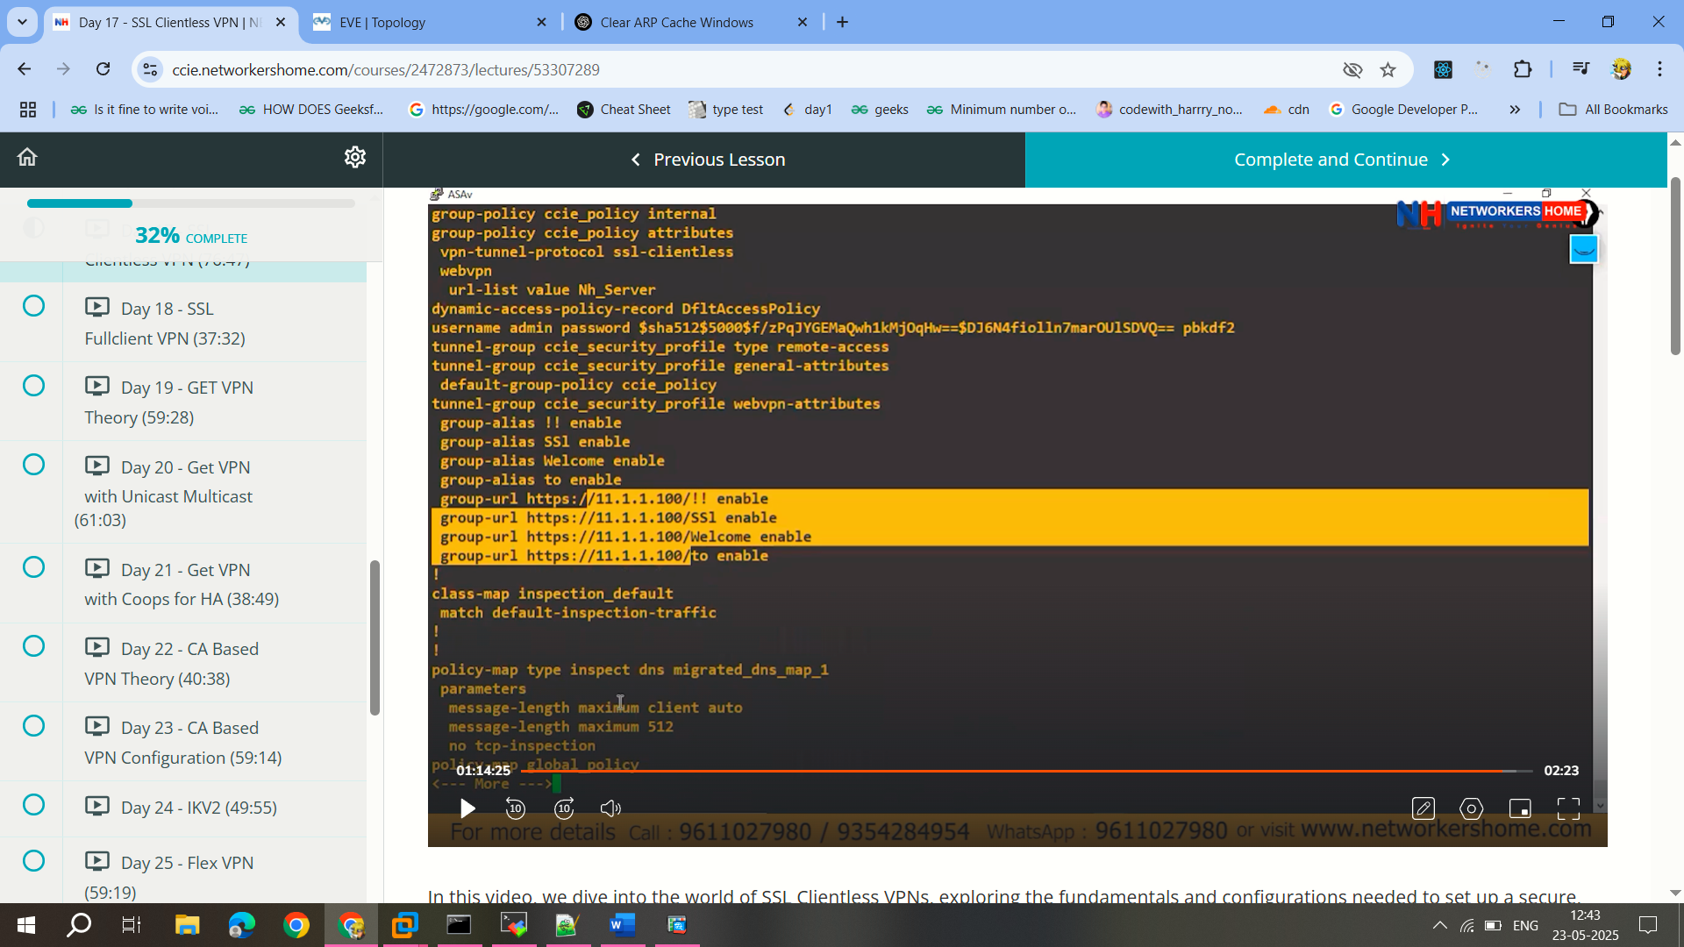

With out Centralize database/server:

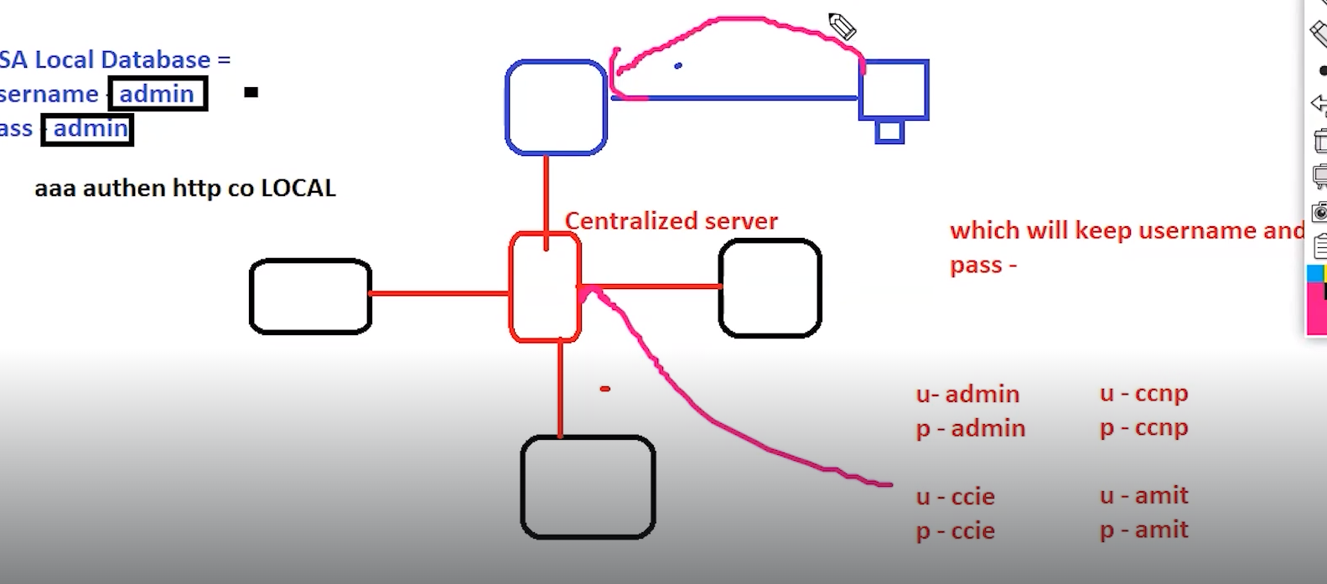

With centralize database, the username and password is checked in the centralized server database.

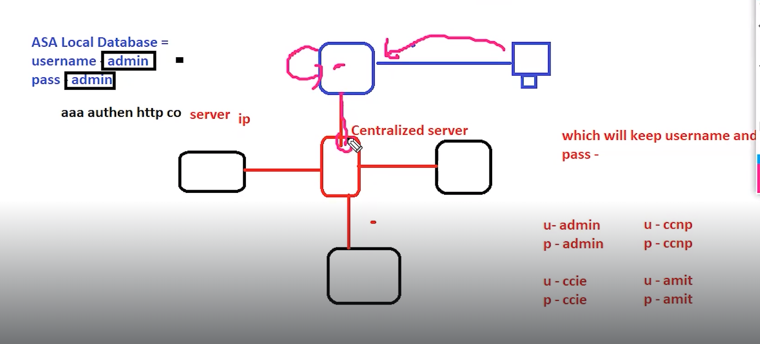

**FullClient Vpn:**

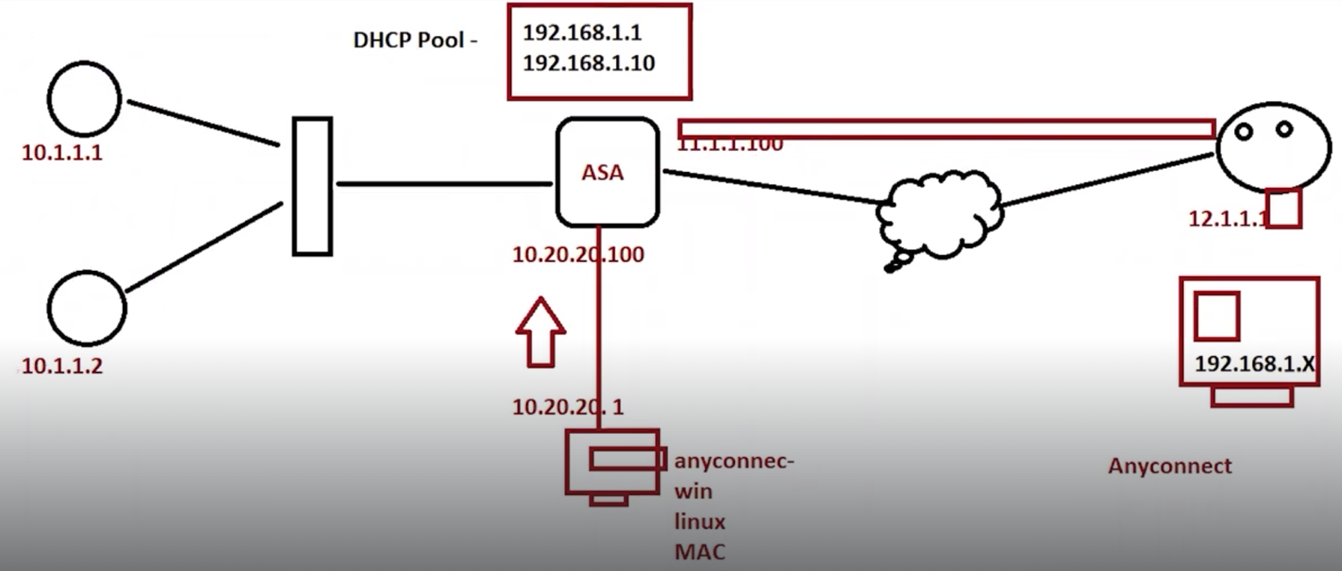

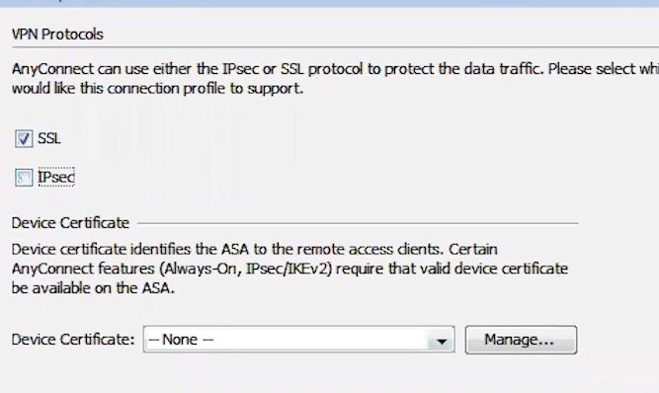  
 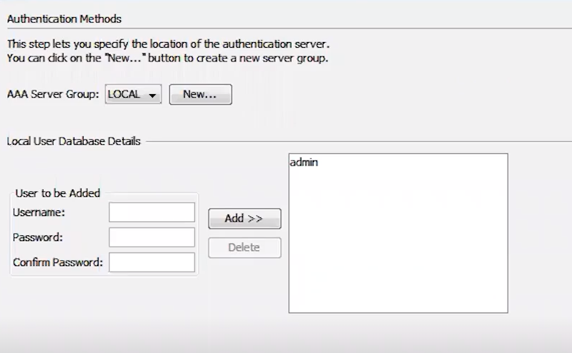

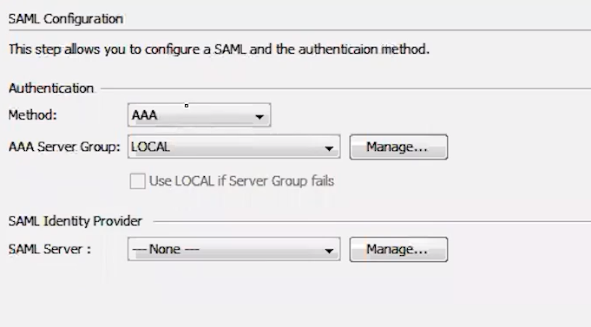  
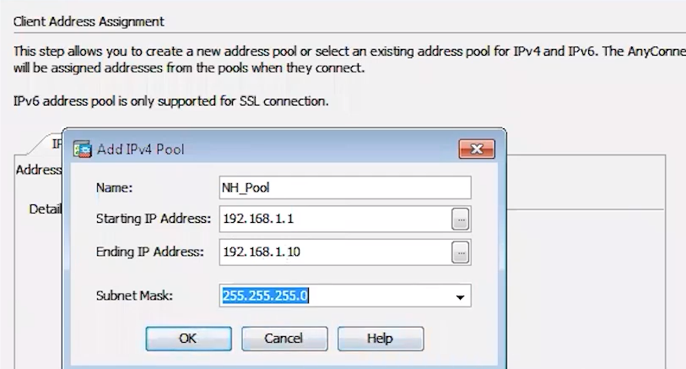  
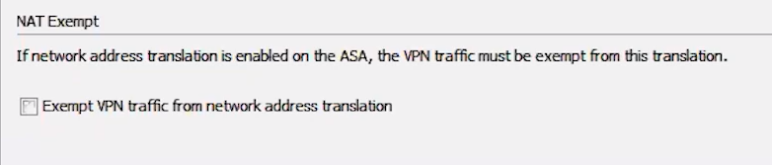

**SSL MESSAGE EXCHANGE:**

* **Client Hello**:
  + The client initiates the communication with a "Client Hello" message, specifying the SSL version, a random number (32 bytes), session ID, cipher suite, compression method, and SSL extensions.
* **Server Hello**:
  + The server responds with a "Server Hello" message, indicating the selected protocol version, server random number, session ID, selected cipher suite, and compression method.
* **Server Certificate**:
  + The server sends its certificate, which is encrypted and verified by the client to ensure authenticity.
* **Server Key Exchange**:
  + The server provides a public key for secure communication, known as the server key exchange.
* **Server Hello Done**:
  + The server indicates it has completed its part of the handshake with the "Server Hello Done" message.
* **Client Key Exchange**:
  + The client generates a pre-master key, encrypts it with the server's public key, and sends it to the server. This pre-master key is used to derive the master key.
* **Generating Master Key**:
  + Both client and server use the pre-master key and their respective random numbers to generate a master key using a pseudo-random function.
* **Change Cipher Spec and Finished Messages**:
  + The client and server exchange "Change Cipher Spec" messages, indicating that subsequent messages will be encrypted. They then send "Finished" messages to confirm the handshake process.
* **Server and Client Authentication**:
  + The discussion includes scenarios where both server and client authenticate each other, necessitating certificates from both parties.
* **Session Resumption**:
  + There is a brief mention of session resumption, where a previous session can be resumed using existing session parameters.

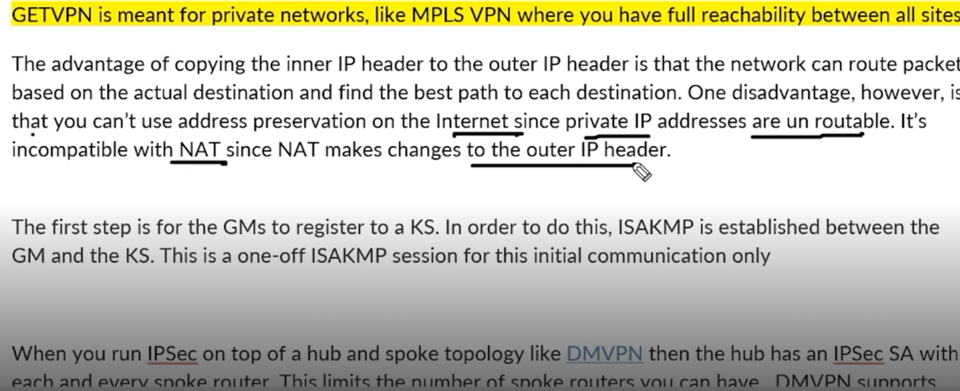

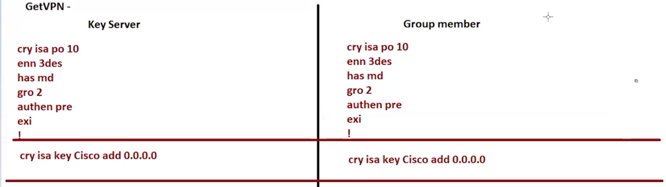

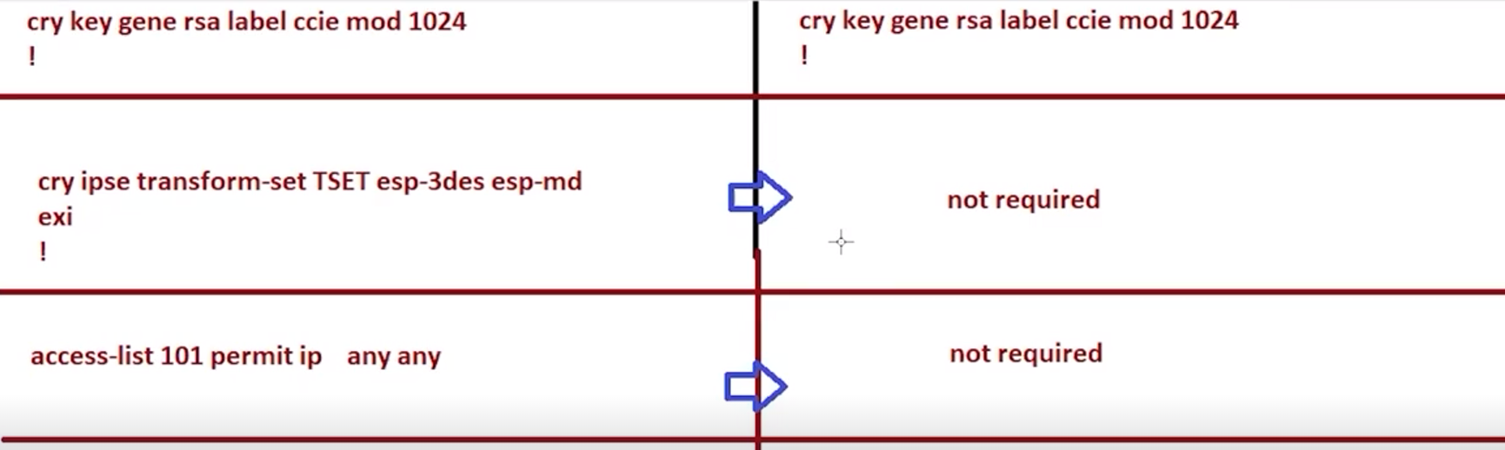  
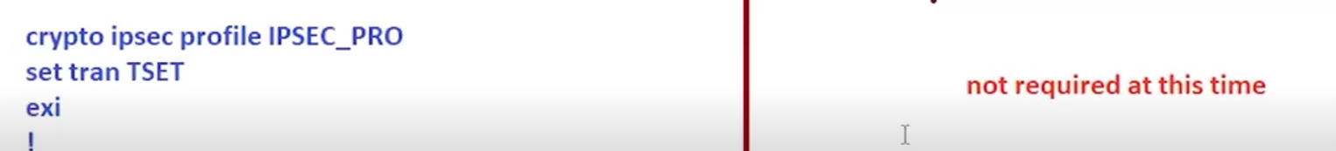  
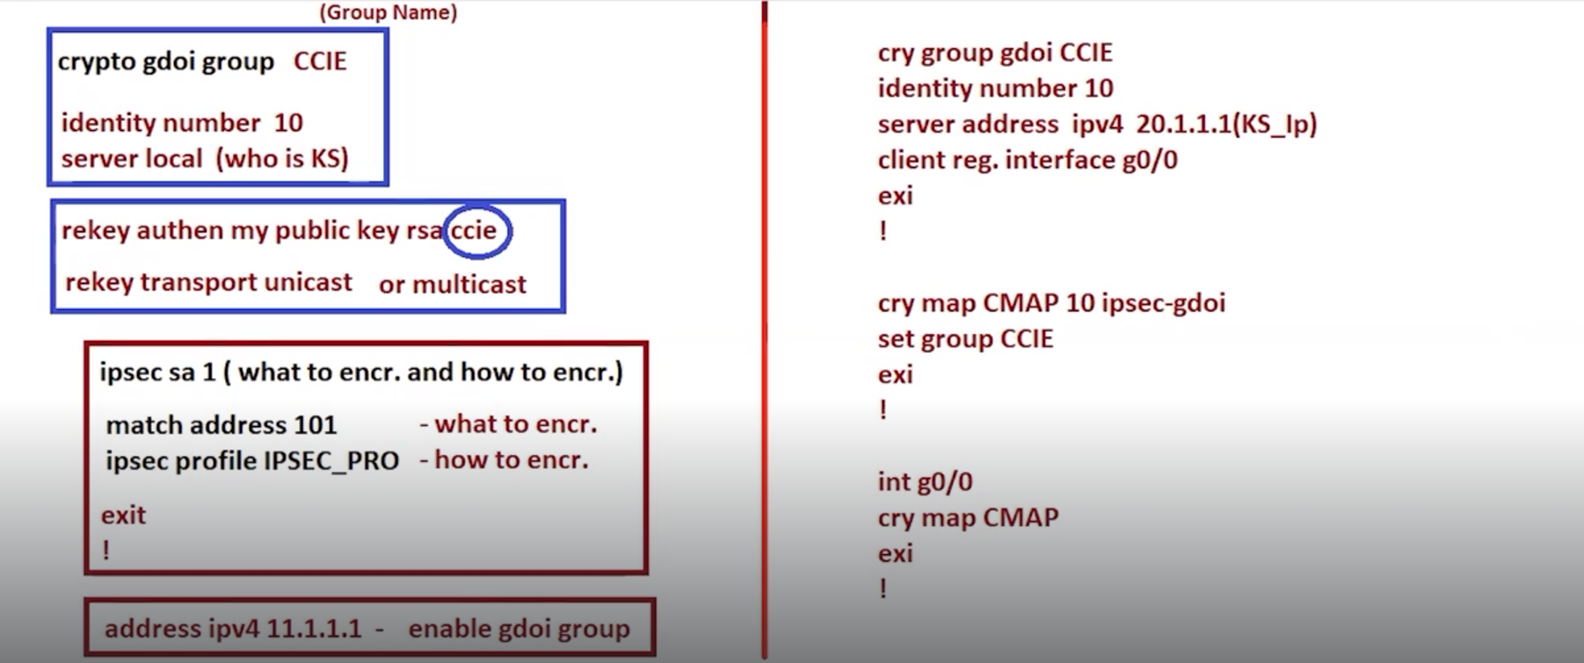  
access-list <no> permit ip 10.1.1.0 <wildcard-mask> 10.1.1.0 <wildcard mask>  
rekey authentication mypubkey rsa shan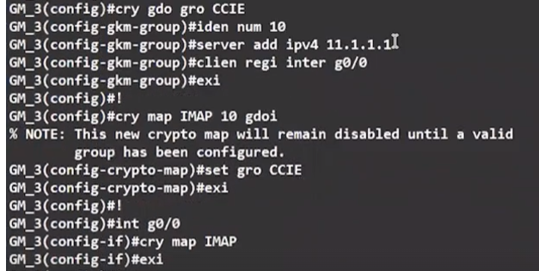

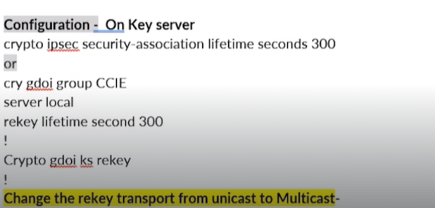

MULTICAST IF WANT

